Information on tourist spots around Ojiya

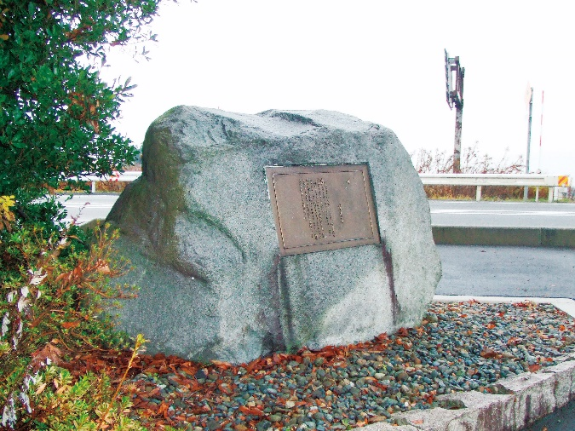
Ryotarō Shiba, The Monument of Tōge

Ryotarō Shiba is one of the most famous Japanese writers best known for his historical novels. On the literature monument built in 1993 as a bridge “koshi-no-ōhashi” was opened, a quote from his bestseller novel “Tōge” (mountain pass) which the scenes are Enoki tōge and Mt. Asahi is inscribed. The quote describes the fierce battle of Hokuetsu that happened at Enoki tōge and Mt. Asahi. On the back, his thoughts for Tsugunosuke Kawai, the commander of the Nagaoka army are inscribed.
The monument was placed on the way to Enoki tōge and Mt. Asahi battlefield as Shiba wanted to so that it faces the historical places.
At Jigan-ji(temple), there is one more stone monument with a note of Shiba is on. He came to Ojiya to do some research for his novel “Tōge”, and when he visited Jigan-ji where “Ojiya dannpan” (peace negotiation) took place, he left a note, which was to be inscribed later. From the sentences, we can see how much Shiba admired Tsugunosuke Kawai.

Address: Takanashi-chō, Ojiya (west end of koshi-no-ōhashi)

